|  |  |
| --- | --- |
| **CURRICULUM VITAE** |  |
|  | |

1. 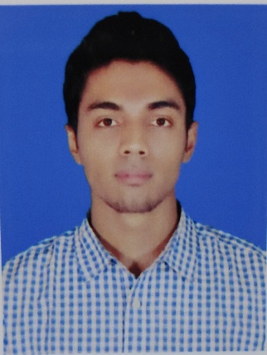**K. M SHAHADAT HOSSAIN**

West Shahid Nagar, Oxygen, Baizid

Chattogram

Mail : shahadathossain98@gmail.com

Cell : 01712882320

|  |
| --- |
|  |
| **Academic Credentials** |
|  |

|  |  |
| --- | --- |
|  | **Diploma In Engineering** |
| Department | Environmental Engineering |
| Institution | Chattogram Polytechnic Institute |
| Board | Bangladesh Technical Education Board (BTEB) |
| Passing Year | 2019 |
| Result | 2.55 out of 4.00 |

|  |  |
| --- | --- |
|  | **Secondary School Certificate (VOC)** |
| Department | Computer Technology |
| Institution | Chittagong Technical College |
| Board | BTEB |
| Passing Year | 2015 |
| GPA | 4.21 out of 5.00 |

|  |  |
| --- | --- |
|  | **Industrial Training** |
| Course Name | Waste And Garbage Collection Treatment Plant |
| Duration | Six Months |
| Organization | Chittagong City Corporation |

|  |  |
| --- | --- |
|  | **Working Experience** |
| Company Name | S. A Paribahan (Nasirabad Branch) |
| Position | Parcel Assistant |
| Served From | 06 February 2017 |
| Served Till | 04 September 2019 |

|  |
| --- |
|  |
| **Personal Details** |
|  |

Name : A. K. M SHAHADAT HOSSAIN

Sex : Male

Father’s Name : Late. Abul kashem

Mother’s Name : Ferdwousi Begum

Date Of Birth : 17th July 1998

Marital Status : Unmarried

Nationality : Bangladeshi

Religion : Islam

Height & Weight : 5’11” & 62 kg

Permanent Address : Village – Alam Nagar, Post Office – Nabi Nagar, Police station – Nabi Nagar, District – B. Baria

|  |
| --- |
|  |
| **Career Object** |
|  |

To build up career in a challenging position to face any challenge in the field of Environmental Engineering. Where the contribution will be acknowledge.

|  |
| --- |
|  |
| **Hobbies & Interest** |
|  |

Interest on Traveling, Listening Music, Watching Movie & Drama, Writing Poem, Playing Cricket Creative works & Working in the Challenging Environment.

|  |
| --- |
|  |
| **Language Skill** |
|  |

Fluent Speaking and Writing In Both English & Bangla.

|  |
| --- |
|  |
| **Social Work** |
|  |

Willing to serve the society, in the way of helping such as poor people, orphanage & autistic child.

|  |  |  |
| --- | --- | --- |
|  | **References** |  |
| Md. Selim Uddin | Mohammad Mashuqur Rahman Sikder | Shah Rakib Uddin Ahmed |
| Chief Instructor | Deputy Secretary | Director, Distribution |
| Environmental Technology | Ministry of Commerce | Techno Drugs Ltd |
| Chattogram Polytechnic Institute | Cell : 01712 714063 | Cell : 01313 011144 |
| Cell : 01819-61418 | Mail : sikder08@gmail.com | Mail : shahrakibuddin@gmail.com |
| Mail : mosaud_cpi@yahoo.com. |  |  |

**A. K. M SHAHADAT HOSSAIN**